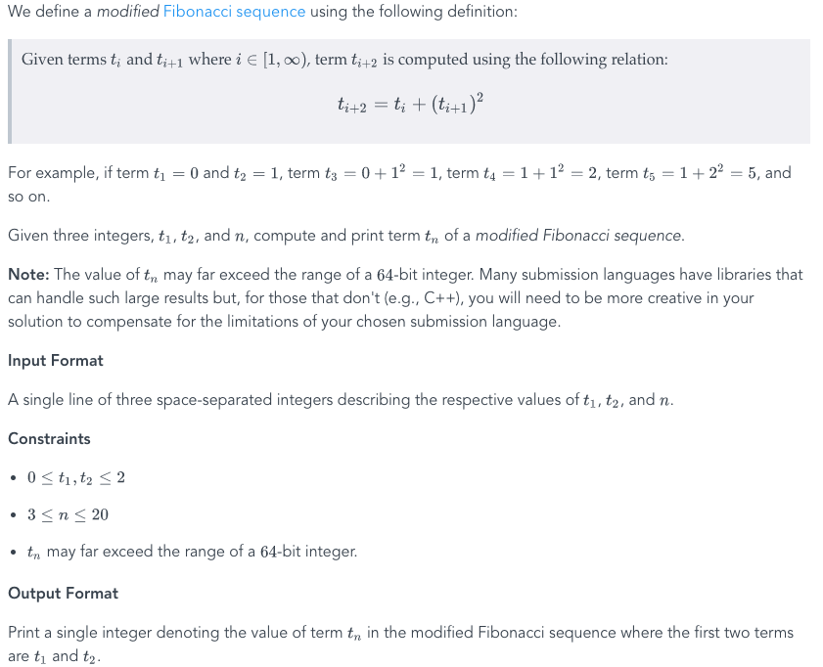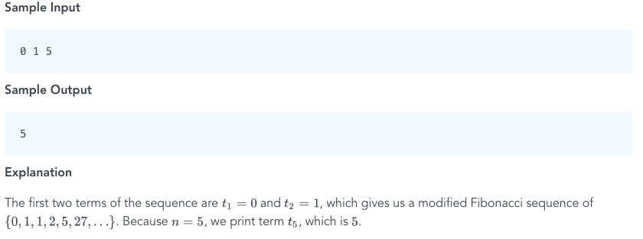1)

2) <https://plnkr.co/edit/7tsP0DAs5NZISDN8SZJi?p=preview> Submitted by Chris Marfia.

3) The creativity challenge is to rebuild/wireframe a new daugherty.com website mainpage. Everyone should put their own creative spin on it. You can either use a wireframing application or spin up a local app with create-react-app/vue-cli/etc. This can either be done in groups of two or alone. At 12:40, I will have two outside judges come in to review the wireframes/apps. The winner is decided by them.

Good luck!!!